**Plasma donor Application**

1. ***Background/ Problem Statement***

Although the government is carrying out Covid vaccination campaigns on a large scale, the number of vaccines produced is not enough for all the population to get vaccinated at present. And with the corona positive cases rising every day, saving lives has become the prime matter of concern. As per the data provided by WHO more than 3 million people have died due to the coronavirus (<https://covid19.who.int/>). However, apart from vaccination, there is another scientific method by which a covid infected person can be treated and the death risk can be reduced. This plasma therapy is an experimental approach to treat corona-positive patients and help them recover. This plasma therapy is considered to be safe & promising. A person who has recovered from Covid can donate his/her plasma to a person who is infected with the coronavirus.

This system proposed here aims at connecting the donors & the patients by an online application. By using this application, the users can either raise a request for plasma donation or requirement.

1. ***Working of the Project***

This system is used if anyone needs a Plasma Donor. This system comprises of Admin and User where both can request for a Plasma. In this system there is something called an active user, which means the user is an Active member of the App and has recovered from Covid 19, only such people are recommended here for Plasma Donation. Both parties can Accept or Reject the request. User has to Upload a Covid Negative report to be able to Donate Plasma.

***Advantages***

* + App already filters the Active Members.
  + Here a User can be a giver as well as a borrower.

***System Description***

The system comprises of 2 major modules with their sub-modules as follows:

**Admin**

* **Login:** Admin can login into his account using id and password.
* **Active User:** Admin can view all active users.
* **Plasma Request:** Admin can raise request for plasma donation to an Active User.
* **User Request:** Admin can accept or reject donor requests on basis of user report.

**User**

* + **Register:** User can register using personal details.
  + **Login:** User can login into his account using email id and password.
  + **Request for Plasma:** User can raise request for plasma donation.
  + **Report:** User need to upload their report of been successfully recovered from COVID19.
  + **Emergency Request:** User can raise request for plasma in emergencies.

***3. Project Life Cycle***

The waterfall model is a classical model used in system development life cycle to create a system with a linear and sequential approach. It is termed as waterfall because the model develops systematically from one phase to another in downward fashion. The waterfall approach does not define the process to go back to the previous phase to handle changes in requirement. The waterfall approach is the earliest approach that was used for software development.

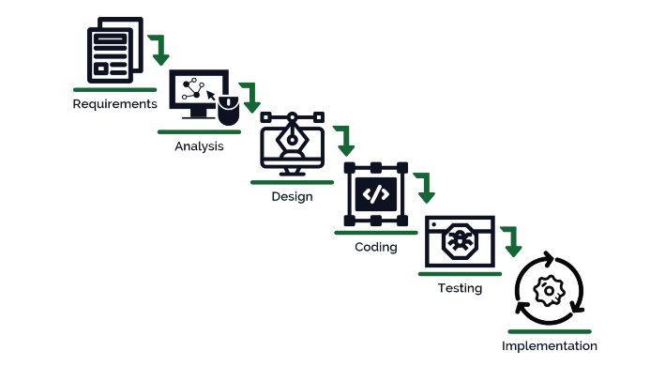

***4. System Requirement***

***Hardware Requirement***

**Laptop or PC**

* I3 processor system or higher
* 4 GB RAM or higher
* 100 GB ROM or higher

**Android Phone (6.0 and above)**

**Laptop or PC**

* Windows 7 or higher
* Android Studio

***5. Limitation***

* Wrong inputs will affect the project outputs.
* Internet Connection is mandatory.
* Reports are not Verified

***6. Application*** – This system can be used by any User who wants to donate or find a donor for Plasma.

***7. Reference***

* https://ccpp19.org/donors/index.html